**2022-2023**

**Dr. Haider Mahdi Lieth**

STAGE :2ND YEAR SEMESTER :1ST CODE: ME214

2022-2023

CHAPTER TWO : SOLDIFICATION AND THERMAL EQUILEBURIUM DIAGRAMS

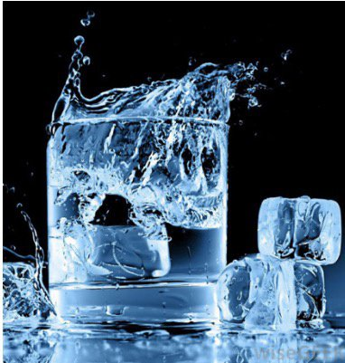

**Solidification**

The change of matter from the liquid state to the solid-state at a particular temperature is called solidification or freezing.

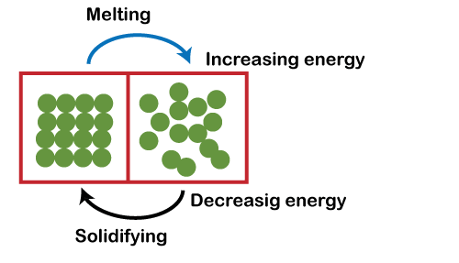This occurs when the temperature of a liquid is lowered below its freezing point. Although most materials' freezing point and melting point are the same temperatures, this is not the case for all substances, so freezing point and melting point are not interchangeable terms. Solidification is always an exothermic process that means heat is released when a liquid changes into a solid.

In solidification, a solid phase is nucleated and grows with a crystalline structure. Where a solid crystalline phase does not nucleate in the cooling process, and glassy structures are formed. Several examples of solidification may be found in everyday life, such as:

* Freezing of water to form ice
* Solidification of melted candle wax

**Cooling Curves**

We can summarize our discussion at this point by examining cooling curves. A cooling curve shows how the temperature of a material (in this case, a pure metal) decreases with time Figure below. The liquid is poured into a mold at the pouring temperature, point A. The difference between the pouring temperature and the freezing temperature is the superheat. The specific heat is extracted by the mold until the liquid reaches the freezing temperature (point B). Alloys frequently solidify over a range of temperature (between the liquid and solidus lines) .In this case the latent heat is released progressively as the temperature falls between the liquidus and solidus. The cooling curve does not therefore show a shelf at constant temperature, but the cooling rate is reduced by the progressive release of latent heat.

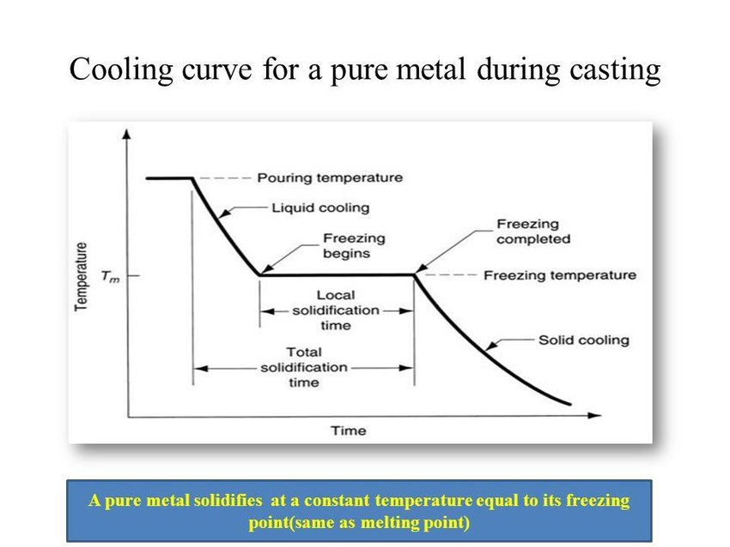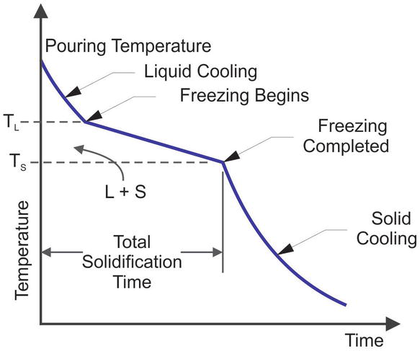

solidification of alloys

**Nucleation**

the initial process that occurs in the formation of a crystal from a solution, a liquid, or a vapour, in which a small number of ions, atoms, or molecules become arranged in a pattern characteristic of a crystalline solid, forming a site upon which additional particles are deposited as the crystal grows.

the phenomenon of nucleation is general and is associated with phase transformations. We expect a material to solidify when the liquid cools to just below its freezing (or melting) temperature, because the energy associated with the crystalline structure of the solid is then less than the energy of the liquid. This energy difference between the liquid and the solid is the free energy per unit volume and is the driving force for solidification.

**Rate of Nucleation** The rate of nucleation (the number of nuclei formed per unit time) is a function of temperature. Prior to solidification, of course, there is no nucleation and, at temperatures above the freezing point, the rate of nucleation is zero. As the temperature drops, the driving force for nucleation increases; however, as the temperature decreases, atomic diffusion becomes slower, hence slowing the nucleation process.

**Growth Mechanisms**

Once the solid nuclei of a phase form (in a liquid or another solid phase), growth begins to occur as more atoms become attached to the solid surface. In this discussion, we will concentrate on the nucleation and growth of crystals from a liquid. The nature of the growth of the solid nuclei depends on how heat is removed from the molten material. Let’s consider casting a molten metal in a mold, for example. We assume we have a nearly pure metal and not an alloy (as solidification of alloys is different in that in most cases, it occurs over a range of temperatures). In the solidification process, two types of heat must be removed: the specific heat of the liquid and the latent heat of fusion. The **specific heat** is the heat required to change the temperature of a unit weight of the material by one degree. The specific heat must be removed first, either by radiation into the surrounding atmosphere or by conduction into the surrounding mold, until the liquid cools to its freezing temperature. This is simply a cooling of the liquid from one temperature to a temperature at which nucleation begins. We know that to melt a solid we need to supply heat. Therefore, when solid crystals form from a liquid, heat is generated! This type of heat is called the **latent heat of fusion (ΔHf).** The latent heat of fusion must be removed from the solid-liquid interface before solidification is completed. The manner in which we remove the latent heat of fusion determines the material’s growth mechanism and final structure of a casting.  **Dendritic Growth**

When the liquid is not inoculated and the nucleation is poor, the liquid has to be undercooled before the solid forms .Under these conditions, a small solid protuberance called a dendrite, which forms at the interface, is encouraged to grow since the liquid ahead of the solidification front is undercooled. The word dendrite comes from the Greek word dendron that means tree(Figure below). As the solid dendrite grows, the latent heat of fusion is conducted into the undercooled liquid, raising the temperature of the liquid toward the freezing temperature. Secondary and tertiary dendrite arms can also form on the primary stalks to speed the evolution of the latent heat.

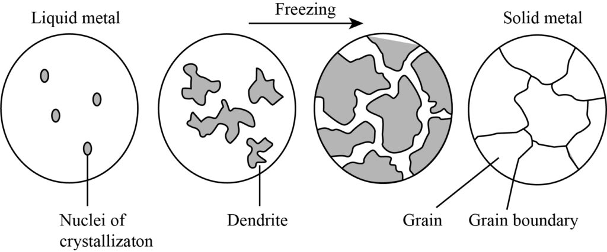

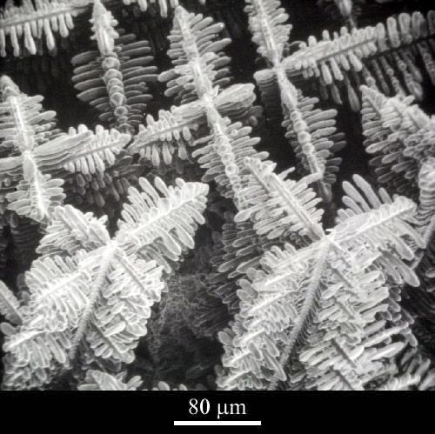

Figure (a) schematic dendrite growth (b) Scanning electron micrograph of dendrites

Dendritic growth continues until the undercooled liquid warms to the freezing temperature. Any remaining liquid then solidifies by planar growth. The difference between planar and dendritic growth arises because of the different sinks for the latent heat of fusion. The container or mold must absorb the heat in planar growth, but the undercooled liquid absorbs the heat in dendritic growth. more dendritic growth occurs. If the liquid is well-inoculated, undercooling is almost zero and growth would be mainly via the planar front solidification mechanism.

**Equilibrium Diagrams**

When a pure metal solidifies it changes from a liquid to a solid state. An intermediate state of liquid and solid exists (sometimes known as the pasty state). These states are known as phases, a phase being defined as regions that differ from one another, either in composition or in structure or in both. In a metal the liquid state consists of atoms randomly arranged whereas in the solid state the atoms are arranged regularly in crystal lattices. Therefore the structure of the two states is different and is referred to as phases. When a pure metal is cooled from the liquid state is produces a cooling curve as in Figure below. The change from the liquid to the solid state occurs at a definite temperature. Where solidification begins and finishes at the same temperature but the time increases. Examples of metals that have this are lead, copper, aluminum. A pure metal solidifies at one fixed temperature, a fact which can be checked by plotting a cooling curve. A cooling curve may be obtained by melting a small amount of a metal and recording the temperature drop at suitable time intervals as this metal solidifies (the metal must be allowed to cool very slowly i.e. under equilibrium conditions) . We can then plot a graph of temperature against time to give us the cooling curve for that particular metal. However during the cooling of an alloy the solidification occurs gradually during a fall in temperature. An example of this would be Copper Nickel creating a solid solution. This is depicted in Figure . Unlike pure metals alloys solidify over a range of temperatures. Below the temperature at which the alloy begins to solidify and the temperature when it is completely solidified the alloy is in a "pasty" state gradually becoming stiffer as the lower limit of the solidification range is approached. Therefore for any alloy there is a definite temperature at which solidification begins and an equally definite point where it ends.

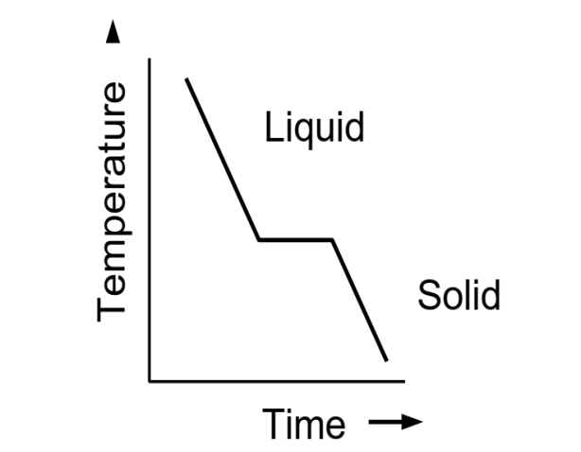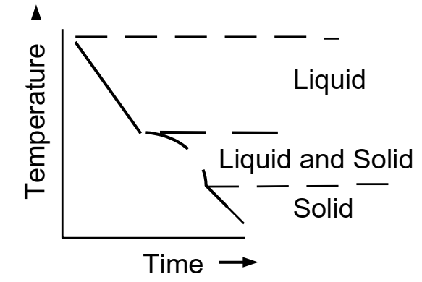

**Alloying metals**

Most pure metals are soft and not very useful in their pure state. Their are of course exceptions i.e copper is an excellent electrical conductor in its pure state. Therefore in order to increase properties like strength, hardness and corrosion resistance we mix two or more pure metals together to give us an alloy. Everyday examples of alloys include Bronze which is an alloy of Copper and Tin where the Tin content is usually less than 20%.

**Equilibrium**

Equilibrium may be defined as a state of balance of stability. When a metal solidifies, equilibrium will occur under conditions of slow cooling where the fall in temperature is small in relation to the time elapsed. To achieve equilibrium it would be necessary, at every stage of cooling, to give the alloy elements time to diffuse (mix through on another) which would lead to a state that each grain of metal would have the same composition throughout. Complete diffusion seldom takes place in casting because solidification usually takes place before diffusion is complete.

**Thermal Equilibrium diagrams.**

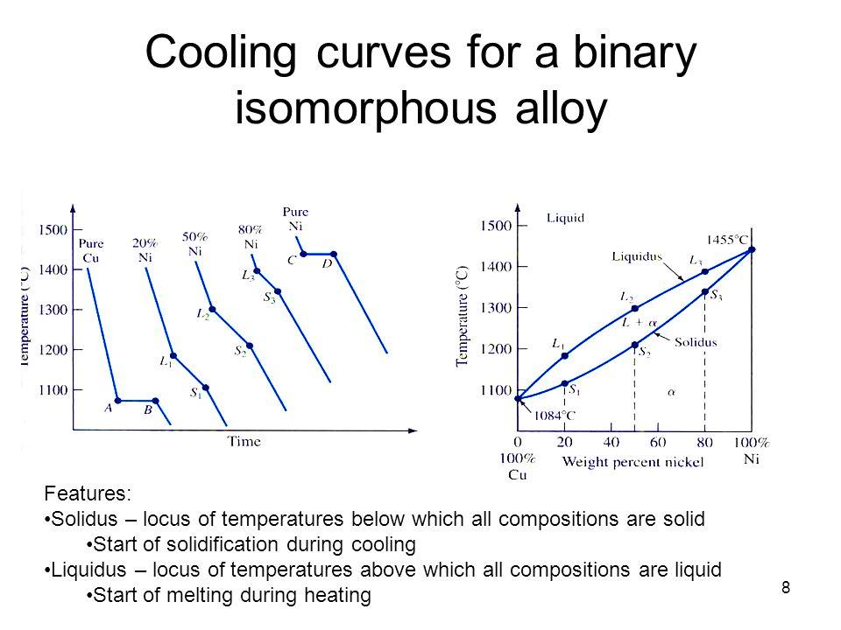Instead of dealing with several different cooling curves for any alloy a quicker graph has been created using the various arrest points of all the alloys. When these points are marked on a graph and joined up we get a thermal equilibrium diagram which looks like this in Figure below.

***1. Solid Solution Alloys***

A solid solution occurs when we alloy two metals and they are completely soluble in each other. If a solid solution alloy is viewed under a microscope only one type of crystal can be seen just like a pure metal. Solid solution alloys have similar properties to pure metals but with greater strength but are not good electrical conductors.

***A. Substitutional solid solution***

The name of this solid solution tells you exactly what happens as atoms of the parent metal ( or solvent metal) are replaced or substituted by atoms of the alloying metal (solute metal) In this case, the atoms of the two metals in the alloy, are of similar size. Here we see the brown atoms have been replaced or substituted by the blue atoms. Depicted in Figure below.

**solvent (s)** is a substance that dissolves a solute, resulting in a solution.

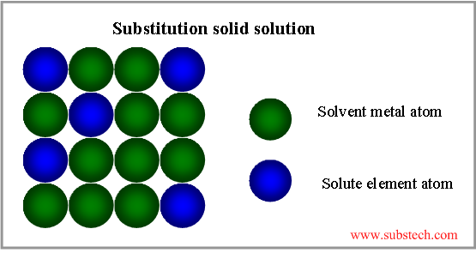**solute** is a substance that can be dissolved by a solvent to create a solution.

***B. Interstitial solid solution***

In interstitial solid solutions the atoms of the parent or solvent metal are bigger than the atoms of the alloying or solute metal. In this case, the smaller atoms fit into interstices i.e spaces between the larger atoms. The smaller atoms are small enough to fit into the spaces between the larger solvent atoms. Shown below in Figure below

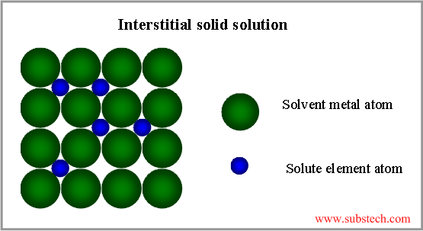

***C. The Lever Rule***

The equilibrium diagram for a solid solution alloy that we have just been dealing with contains two distinct phases, liquid and solid solutions. Between the liquidus and solidus lines these two phases exist together in equilibrium and hence the area between the curves is known as the two phase region.  
If a horizontal line is drawn through the two phase region, such a line is called a *tie line.*

(weight W1) ( distance X1) = (weight W2) (distance X2)

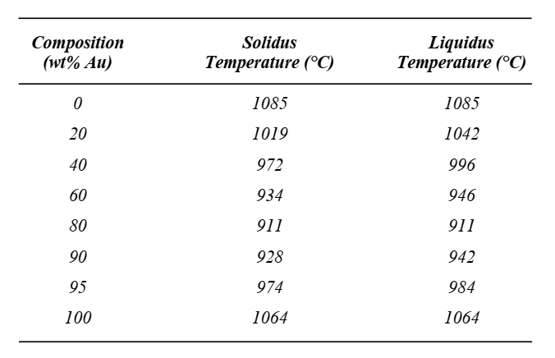***Example 1:-*** Given here are the solidus and liquidus temperatures for the copper–gold system. Construct the phase diagram for this system and label each region.

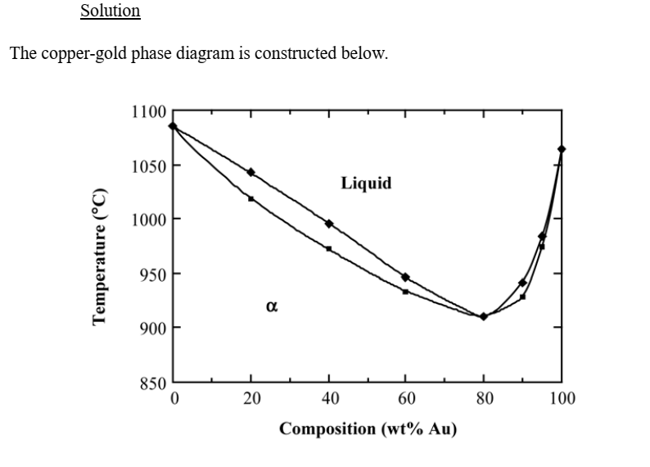

**BINARY ISOMORPHOUS SYSTEMS**

An example of this type of system is afforded by the nickel-copper alloy. Atoms of nickel and copper have the same crystal structure (FCC), nearly identical atomic radii and similar valences.

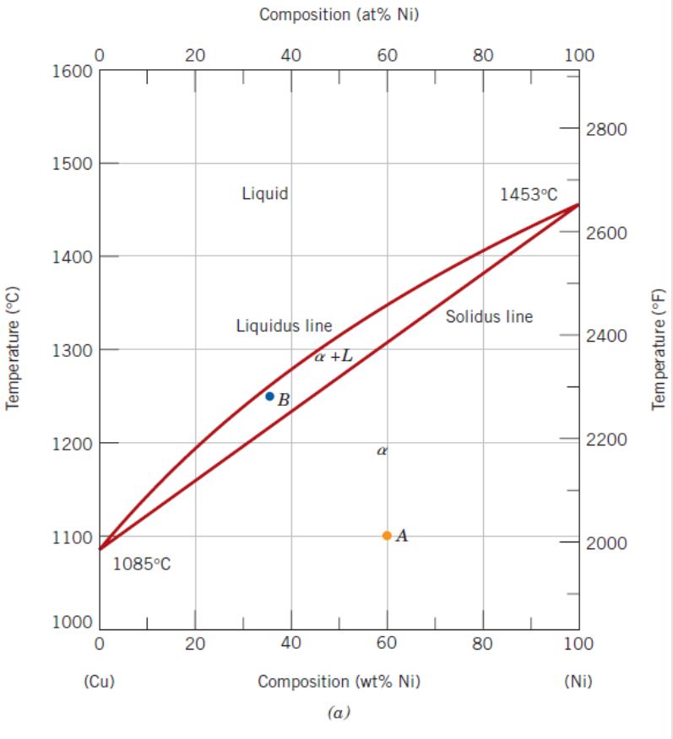

Three different phase regions on the diagram:

1. Liquid L is a homogeneous liquid solution Composed of both copper and nickel.

2. The phase is a substitutional solid solution

consisting of both Cu and Ni atoms, and having an

FCC crystal structure.

3. Two-phase + L region at equilibrium.

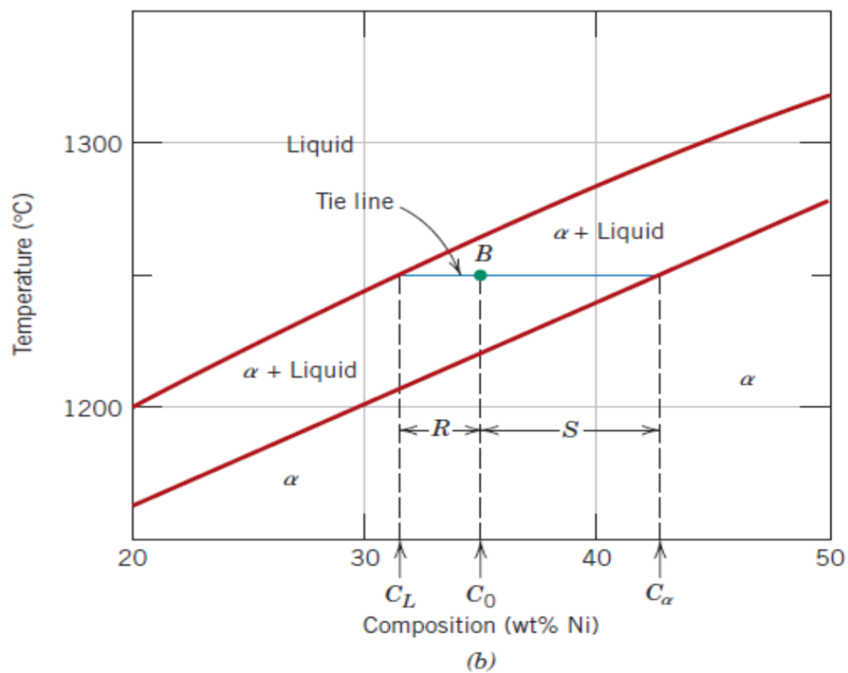***Example 2:*** Determine the composition of each phase in a 35 wt% Ni-Cu alloy at 1300 oC, 1250oC, and 1200oC.

**Solution :-**

The vertical line at 35 wt% Ni represents the overall composition of the alloy:  
• 1300°C: Only liquid is present. The liquid must contain 35 wt%  
Ni, the overall composition of the alloy

* 1250 C: Two phases are present. A horizontal line within the α +‏‏L field is drawn. The endpoint at the liquidus, which is in contact with the liquid region, is at 31.5 wt% Ni-68.5 wt% Cu.

The endpoint at the solidus, which is in contact with the α region, is at 42.5 wt% Ni-57.5 wt% Cu. Therefore, the liquid contains 31.5 wt% Ni-68.5 wt% Cu and the solid contains 42.5 wt% Ni-57.5 wt% Cu.

• 1200 C: Only solid a is present, so the solid must contain 35wt% Ni.

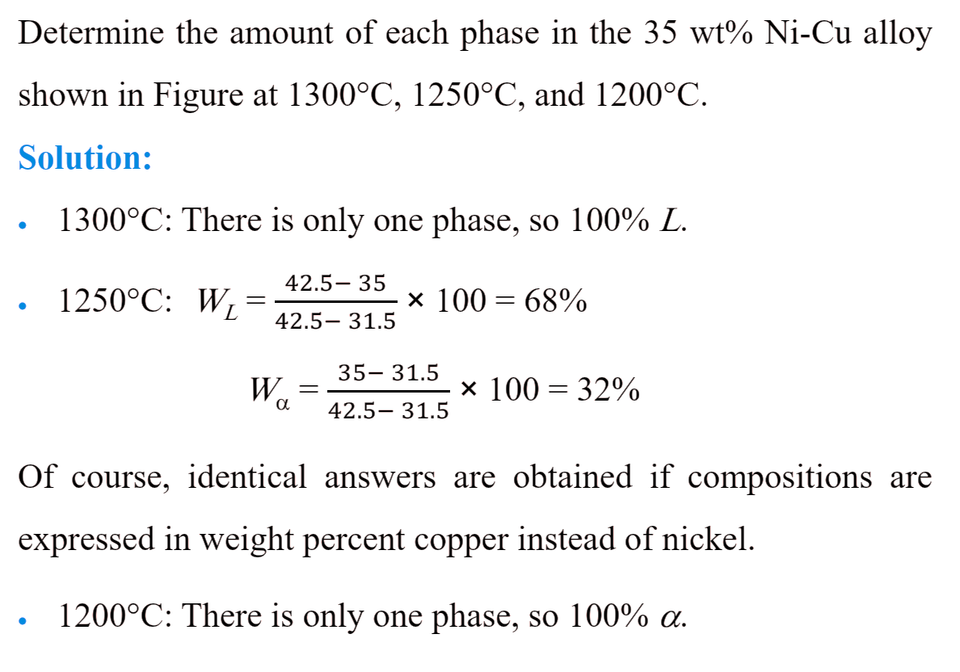***Example 3:***

***2. Eutectic Alloys***

For a binary system three kinds of information are available:

**1. the phases that are present,**

**2. the compositions of these phases, and**

**3. the percentages or fractions of the phases.**